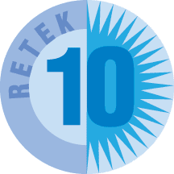 | Retek® Distribution Management  Release Summary  For Versions:  10.2 – November 30, 2002  Retek Labor Management (RLM)  10.3 – April 30, 2003
Corporate Headquarters:  Retek on the Mall  950 Nicollet Mall  Minneapolis, MN 55403  888.61.RETEK (toll free US)  +1 612 587 5000  European Headquarters:  110 Wigmore Street  London  W1U 3RW  United Kingdom  Switchboard:  +44 (0)20 7563 4600  Sales Inquiries:  +44 (0)20 7563 4646 |  | The software described in this documentation is furnished under a license agreement, is the confidential information of Retek Inc., and may be used only in accordance with the terms of the agreement.  No part of this documentation may be reproduced or transmitted in any form or by any means without the written permission of Retek Inc., Retek on the Mall, 950 Nicollet Mall, Minneapolis, MN 55403, and the copyright notice may not be removed without the consent of Retek Inc.  Information in this documentation is subject to change without notice.  Retek provides product documentation in a read-only format to ensure content integrity. Retek Customer Support cannot support documentation that has been changed without Retek authorization.  Retek® Distribution Management™ is a trademark of Retek Inc.  Retek and the Retek logo are registered trademarks of Retek Inc.  This unpublished work is protected by confidentiality agreement, and by trade secret, copyright, and other laws. In the event of publication, the following notice shall apply:  ©2002 Retek Inc. All rights reserved.  All other product names mentioned are trademarks or registered trademarks of their respective owners and should be treated as such.  Printed in the United States of America.

RDM Release Version 10.2

Foundation Elements
Foundation elements provide a flexible tool within the RDM environment that enables better alignment between system configuration and operation workflow. The Foundation elements expand the configuration of the RDM application by enabling greater configuration. The implementation team is better able to manage the application environment at a macro level while having the flexibility to make changes at the micro level. The Foundation elements also allow information gathered from defined processes to be shared with Labor Management to provide better solution for distribution management.
Foundation configuration in RDM allows the DC to define, group and manage items, locations, equipment, and people (and soon vendors). In the distribution center, day-to-day activities are achieved when item, location, equipment, and people characteristics overlap. RDM facilitates the definition of processes for these day-to-day activities according to client-specific requirements. In short, Foundation Basics provides or greater flexibility in definition, setup, and use of the RDM application.
The Foundation components resulted in substantial changes to the Retek Distribution engine. The manner in which replenishment and picking tasks are created have changed to account for Foundation characteristics.

Definitions
- An Item class provides the ability to group items together for processing. Classes are created by applying user-defined rules and default variables to items that group them by like characteristics. The classes are user defined to match the requirements of any facility and are used to manage the facility at a higher level. This provides for:
  - Simplified maintenance and setup of items based on user-defined parameters at any level.
  - Grouping by selected characteristics (e.g., a class of high value items).
  - Grouping by default attributes and characteristics that will be applied to the items within a class.
  - Defining certain business processes that can then be assigned to item classes at an item configuration level (for example, a pallet of an item may support a different process than a carton of the same item).
- A location class provides the ability to group locations together for processing. Classes are created by applying user-defined rules and default variables to locations that group them by like characteristics. The classes are user defined to match the requirements of any facility and are used to manage the facility at a higher level. In RDM, the warehouse is composed of Locations, which may be reserve storage, receiving/shipping doors, WIP processing areas, etc. The Location class definition describes physical attributes, the equipment that can be used, and the type of processing that takes place.
  - The location class model is a definition, or group of characteristics, for a type of location that exists in many places in the warehouse that are generally processed the same way. For instance, a warehouse may have many locations that are exclusively used for case pick operations or refrigerated products. A location class can be defined with all of the characteristics of a case pick location and then applied to many physical locations eliminating the task of defining many similar areas and providing a simple method for redefining these areas as the business changes.
  - Locations are grouped in user-defined zones for manageability. Zones can then be grouped in zone Groups.
  - Locations are further defined through the Location Type. A Location Type describes the physical characteristics of a group of locations. These characteristics include dimensions, capacity, type of location (door, staging, storage), etc.
  - Locations are associated to equipment classes to provide RDM with the data to know what kind of tasks can be executed in the area.
  - Processes are defined for combinations of location and items classes.
- A zone group is several locations grouped in user-defined zones for manageability. By grouping zones during distribution and picking, RDM can provide more flexibility to the DC.
Zone groups will provide sub-grouping of picking assignment for forward case picking lines. Characteristics associated to the maximum weight and cube for each specific zone allow configuration based on product mix or weight to ensure maximum flexibility when building pallets.
- A presentation style defines how the task will be performed (paper, labels, RF screen).
A GUI Presentation Type Editor creates the presentation type (i.e. RF, label, paper, etc.) and associated applicable transaction timing measurements (Real, Pre, and Post timing).
The information in this screen will be tied to a process type to define supported presentation types.
- A process is defined by one task and one presentation style.
A process is defined as a task performed in the DC identified by presentation method (RF, label, etc.), screen (hh_receiving, etc.) and other elements (such as screen navigation, validation rules, data capture, etc.)
Item ‘classes’ and location ‘classes’ can be directly tied to individual processes. This provides the ability add enable processes for locations and items. By adding processes to locations you are specifying that the process can be performed in the location it has been applied to. By assigning processes to items, you will also be specifying the processes that are supported.
This combination of item/location/process allows the system to present the same process in multiple ways.
Process can have unique characteristics such as labor standards to provide greater flexibility.
  - Capture attributes are used to obtain specific information about an item. For example, some items may require the user to capture the serial number. VALIDATE attributes are used to decide what the user will need to verify on the screen. For example, locations where the Location ID is painted on the floor, the user may be required to scan the UPC rather than the Location ID when picking. There are two types of VALIDATE attributes. They are Auto-Populate and Auto Confirm. Auto-populate will pre-populate the field, but the cursor will appear on the field. The User can edit an Auto-populate field. The term auto-confirm will pre-populate the field and the cursor will move to the next field. Auto-populate and auto-confirm can be set at the field level within a pick process screen.
  - Match attributes are used when both item and location need to have the specific attribute on them in order for the item to be stored in that location. These will be only used for putaway and move processes. An example of a MATCH variable could be REFRIGERATED. The refrigerated item cannot be putaway to any location that is not REFRIGERATED. This capability will be added as part of the 10.3 initiative, but the data structure and attribute values exist in RDM 10.2.

Functional Enhancements

Forward Case Picking
Forward case picking refers to a static or dynamic location from which cases are picked and replenishments are directed. These forward picking locations provide new flexibility to better support environments that perform a “pick to belt” or “pick to pallet” operation. The case picking operations utilize the new foundation structure, which support the newly introduced process definition. New configuration parameters defined for the pick zone provide flexibility to optimize pick efficiencies and still achieve maximum service levels to the end customer.

Replenishment Priority
Replenishment asks are prioritized higher for items with pick demand higher than for tasks of items without a pick demand. A new background process continues to monitor replenishments and pick faces to escalate the priority of the task when the pick face is going to be short of merchandise for a pick.

Load Sequencing of Pallets
Load sequencing is driven by a system control parameter. The Route Destination Editor establishes the sequence of how the stores are to be loaded onto the outbound trailer. New user messages are used to identify to an operator that is loading a trailer out of sequence that picked merchandise has not been loaded for the previous destination on the route.

Web ASN Entry of “best-before” Date
If a perishable item is added to an ASN screen, the user must input the “best-before” date. During receiving, the “best before” date will be pre-filled with the ASN value.

Task Queue Quantity Totals
The task maintenance screen has two new fields: CASE PICKS and PALLET PICKS, which include all types of case and bulk picks including replenishment tasks. The numbers in these fields represent the total number of available case picks and pallet picks in the Task Queue.

Cycle Counting
A function key is added to all Bulk and Bulk Replenishment screens. This makes them consistent with the other picking screens to allow the operator to mark the specified location for cycle count.

HAZMAT Code
If there is a HAZMAT code associated with an item in the item master, the code will be displayed on all outbound labels.

Tracking of Skipped Tasks
When using task management, RDM will capture the user that uses the skip key to search for a task other than the one presented to him. The information will be captured in the Activity History Log.

Putaway Screen
The actual location either gets pre-populated in the confirm location, or left blank requiring the user to scan a location. The override logic validates that the overridden location exists in the current putaway plan for the item. A new system parameter turns on/off the confirm quantity logic on the putaway screen.

Rigid Putaway
For an item that has dimensions defined in the system, the physical dimensions are used rather than the liquid cube to determine putaway fit. This will compare the physical dimensions of the pallet (Ti x HI) against the location type dimensions. Ti x Hi dimensions will be used when they are available.

Put-to-Store Case/Multi-SKU Pallets
This involves the capacity to sort full cases through a put-to-store (PTS) operation as well as induct multi-SKU pallets into the PTS operation. At the beginning of each defined working period (day, shift), the system will dynamically assign stores in the PTS grid based on allocations of both reserve and inbound merchandise. The assignment will be a simple sequence of destination IDs. A report will provide visibility on how many put-to containers are estimated for the period.

Max Time Wave
An additional time constraint has been added to the Wave Build screen. On the build query screen, there will be another field added that will state MAX TIME. This will allow the user to input hours and/or minutes desired for the wave processing time and apply it to the Wave Preview calculations. The selection process will accumulate the time for each order it selects until the MAX TIME is reached, resulting in an amount of work generated that fits within the timeframe entered in MAX TIME.

Catch Weight Enhancements
RDM currently supports the ability to manage catch weights for catch weight specific items. This functionality is enhanced to provide further definition around when to catch the weight of the merchandise and what information will be sent through the interface to the host system. All parameters will be defined at either the item or item class level to allow for greater flexibility.
New parameters will drive when the catch weight will be captured. This can be defined to capture weight during receiving, outbound or both.
New parameters will determine how merchandise weight is captured on inbound. The weight can be at the Appointment/PO/line level (total weight for the item on the appointment) or by receiving handling unit (pallet, case, etc.).

Retek Labor Management (RLM)
In November 2002, Retek introduced a Labor Management module as part of its Supply Chain Execution solution. The Labor Management module may be used in conjunction with Retek RDM or as a standalone Retek application integrated to other 3rd party or legacy WMS applications. This is accomplished through an XML-based integration layer.
Retek’s Labor Management Solution (LMS) provides users with the capability to improve labor efficiency, reduce labor spend, and improve resource utilization (facility, equipment) by presenting the user with critical performance information and analytics required to manage and improve logistics operations. Data is collected and a reporting framework provides visibility to productivity and performance for every activity, employee, department, and facility over a user-defined timeframe, enabling management to identify areas in need of improvement.
System Capabilities and Functional Overview
For specific processes, a labor standards definition editor allows users to develop work elements and time standards that make-up a warehouse process. Standards can be historical, estimated, or populated
from a study file. Standards may be built for direct and in-direct activities. The standard may be identified at any level of detail that is appropriate and are built by combining both fixed and variable components of the standard. Travel distance using X, Y, Z coordinates and vehicle speeds (loaded/unloaded, vertical/horizontal) are taken into consideration.
The labor-reporting engine allows the user to compare actual process time to standard time and calculates productivity and performance. Integration with a time & attendance system allows reporting on direct/in-direct functions as well as measured/unmeasured functions.

Bolt-On Solution
The Labor Management module utilizes transaction data from the WMS system. The data is transferred into the Labor module through published APIs using the Retek Integration Bus (RIB). The RIB is the XML-based integration layer that enables other applications to communicate, using industry standards, to Retek applications.

Discrete Labor Standards
The work element definition editor supports labor standards development at the appropriate level of detail. The customer determines how discrete the standard for any activity should be.
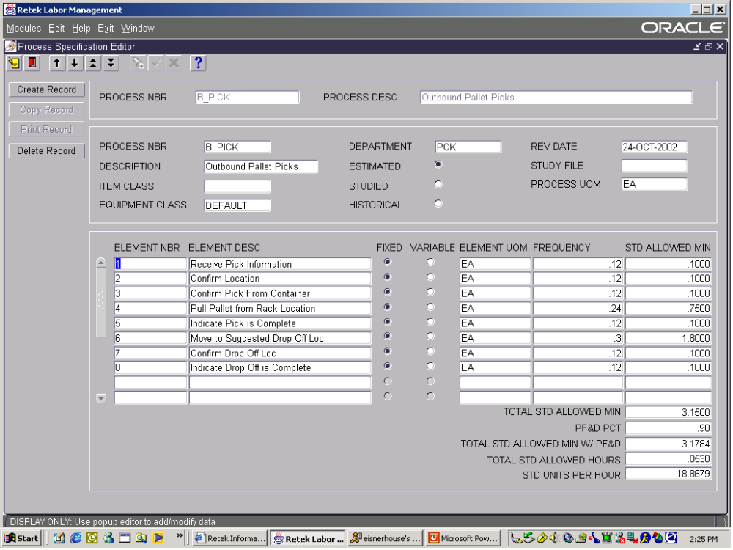

Facility Mapping
Facility mapping using X, Y, Z coordinates and actual distances is supported.
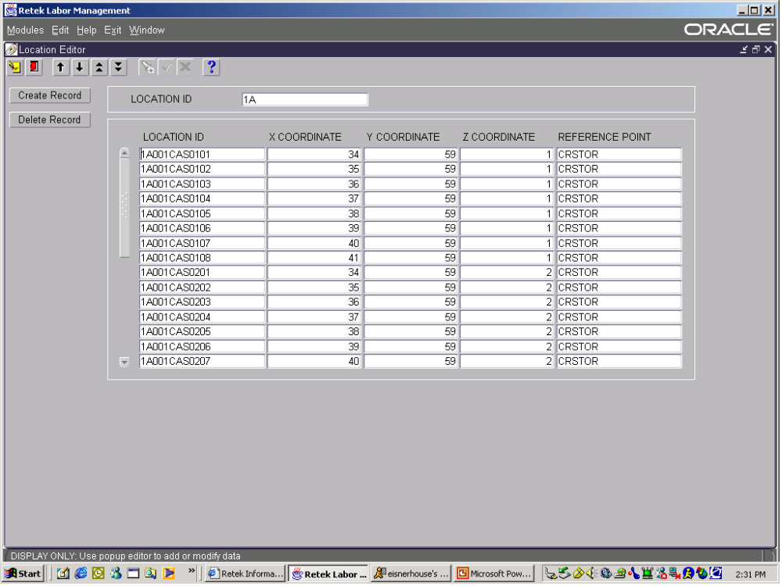

Monitoring Production by Individuals and Teams
Production monitoring is supported and many levels, including individual, team, department, shift, and facility. Direct and Indirect hours are captured and reported.
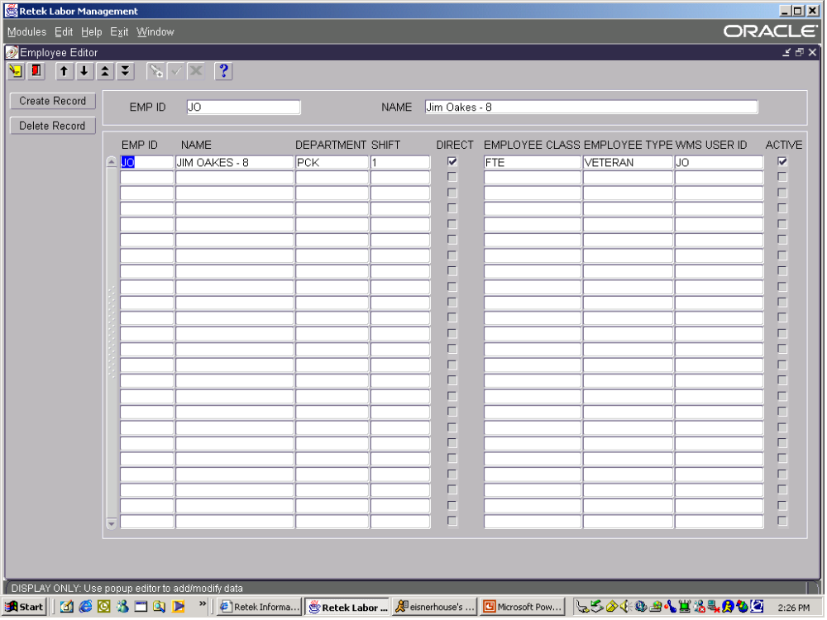

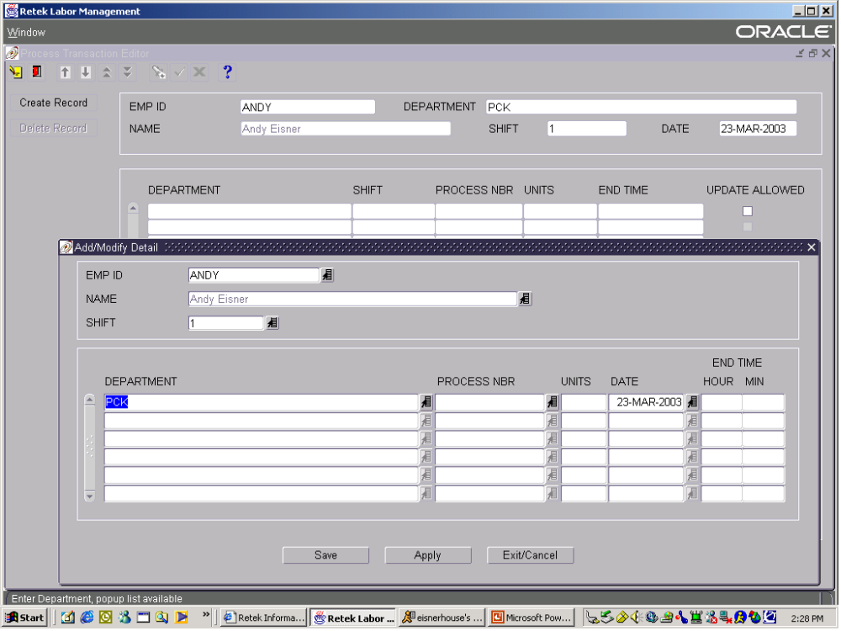

Production Reporting
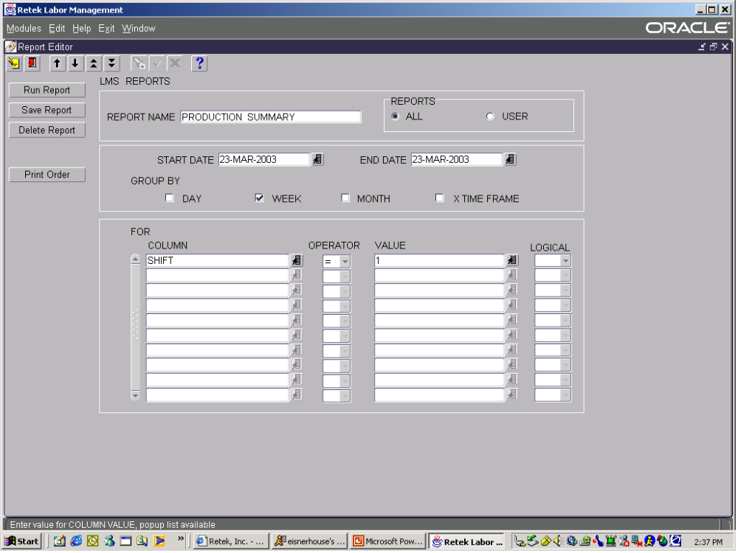
Production reporting is supported for the timeframe (how long), time-measure (day, week, month, user-defined) and content specified by the user –this including, but not limited to individual/team, process, work element, department, shift, facility. Interleaved tasks can be reported on using logical operators.

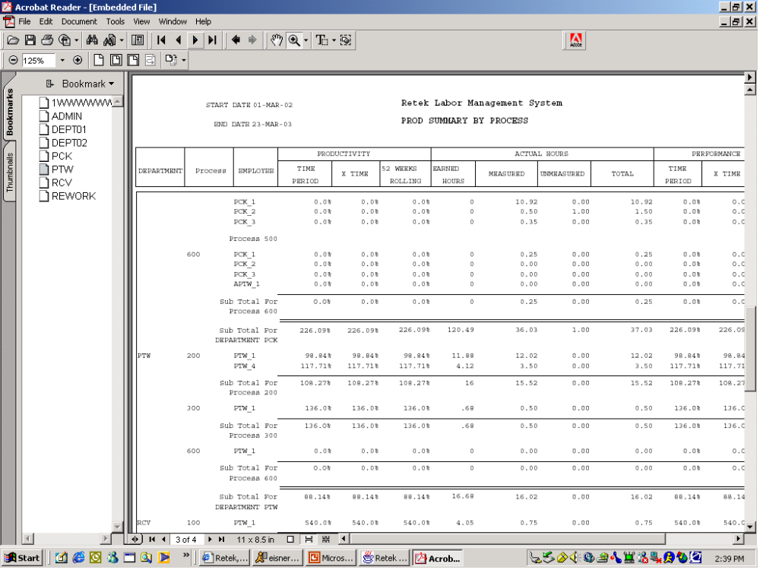

Time & Attendance Interface
The Retek Labor Management module comes with a built-in API to a time & attendance system. The time & attendance system is the basis for providing measured vs. unmeasured performance as well system time vs. paid time performance. Start and end-of-day, as well as breaks/lunches, are fed into the labor module through the time and attendance API.

RDM Release Version 10.3

Functional Enhancements

Putaway
Screen Changes
Putaway has been revamped to have one main screen and several supporting screens behind it to handle the several types of putaway that we support. These include Pallet Putaway (current functionality), Case Putaway (new functionality that allows for putaway of a single case from a pallet into storage), FCP to LTC (current functionality) and Active Putaway. When the user enters the main putaway form, they will only see the prompt to scan a label. Once they have scanned the label, some basic checks will be done to assure that the container is eligible for putaway. Assuming the container/pallet passes these restrictions, the user will be automatically taken to the appropriate supporting screen.
The four supporting screens are Pallet Putaway, Case Putaway, Active Putaway and Active Replenishment Putaway. Pallet Putaway will encompass putting away a full pallet or a standalone container into storage. Case Putaway is the ability to scan a Container that is on a Pallet and putaway just that Case into storage without first disassociating it from the Pallet. Active Putaway is used anytime the user is putting away into a FCP or LTC. Types of active putaway include 1) putting away a full pallet into one or many FCP/LTC locations, 2) putting away a standalone container into an FCP/LTC and, 3) putting away a mixed SKU single container into multiple LTC locations.
Concentric Putaway
For concentric putaway, X, Y and Z coordinates will be assigned to each location. Each location will also be tied to a reference point. The reference points also have X, Y and Z coordinates. The distance between each reference point to all other reference points is stored in RDM. The ‘starting point’ for the concentric putaway logic will always be the picking location for the item.
All locations that fit the specifications for the putaway plan detail line will be identified. Each of those locations will be evaluated to determine its distance from the starting location. If the location being evaluated has the same reference point as the starting location, then we will simply calculate the distance between the two locations. To calculate this distance we will use the following formula for distance between two points in a three dimensional plane:
D = (x₂ - x₁)² + (y₂ - y₁)² + (z₂ - z₁)²
If the location being evaluated and the starting location have two different reference points, then the calculation for distance between these locations will involve three parts. First is the calculated distance from the starting location (pick face) to the reference point of the starting location. Second is the stored value between the two reference points. And finally, the calculated distance from the second reference point to the targeted location. The first and third parts of this equation will be calculated using the formula above for distance between two points in a three dimensional plane. These three numbers will be added together to make up the traveling distance between the two locations. The location determined to have the smallest traveling distance from the item’s picking location will be suggested to the user. In the case of a tie between two locations, the system will pick one selected last.

The following screen shows the RDM Putaway plan Editor with the Concentric Putaway detail option.
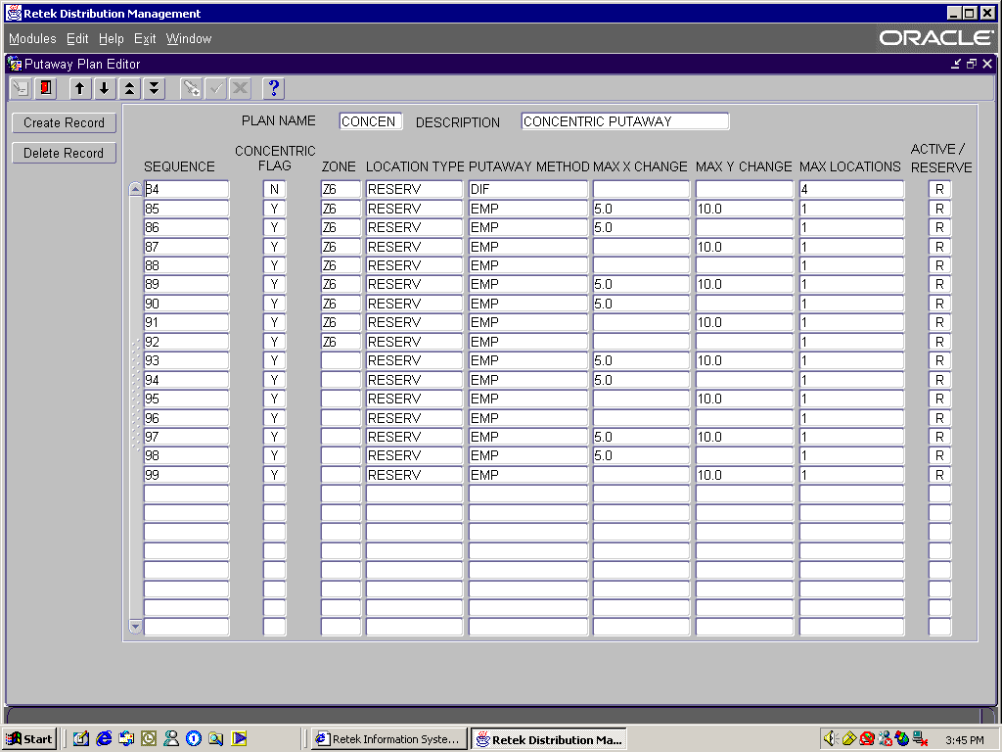
Enhancements to Replenishment
Preplanned (wave-based) replenishment has been enhanced to provide additional flexibility. Configuration options now include:
- Users have the ability to configure the algorithm (at a location level) that preplanned replenishment uses in situations where on-hand quantities in forward pick locations cannot satisfy demand.
- Users are able to define task priorities for situations where demand in a forward pick location exceeds exiting on-hand quantity, where replenishment tasks exist for the location. In such situations, RDM can automatically increase the priority of the replenishments. As demand falls below the quantity on-hand in the location, the replenishment tasks assume their original priorities.
- Users have been given more flexibility with respect to forward picking locations that require replenishments greater than their capacity. Users will be able to place replenishment tasks “on hold” if the quantities will not fit into forward picking locations. Rather than using ‘fit’ by unit quantity in a literal sense, this logic now allows users to define a trigger point at which replenishment tasks will be released for forward pick locations. This will allow the DC to truly build in the use of timing to the release of replenishment picks in order to reduce stock outs in forward pick locations while managing capacities. In this sense, preplanned replenishment is made to work similarly to re-order point replenishment.

View Total Cube and Weight of Orders
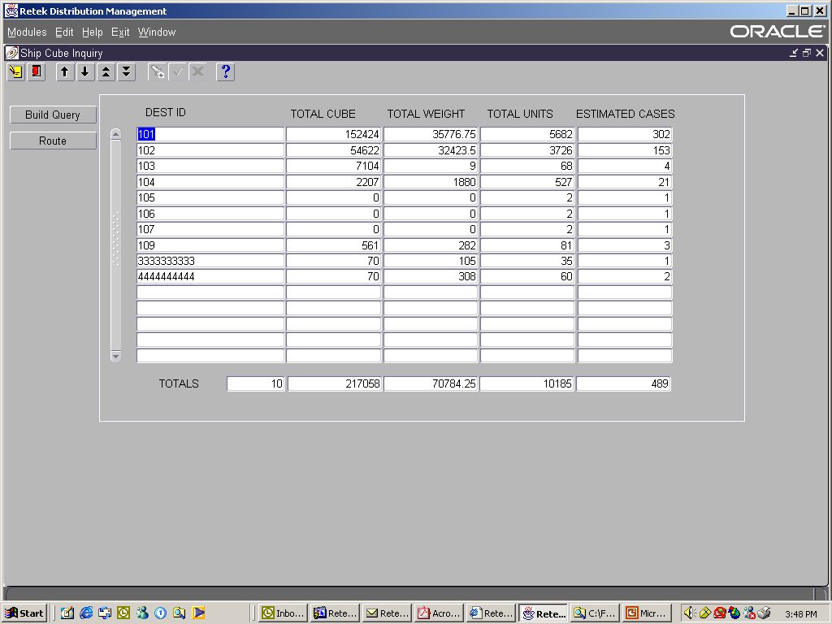
Functionality will be developed to allow the distribution center to see the total cube and weight of orders for a given time period or other user defined criteria. The screen below displays the output of the user defined criteria to provide visibility to the anticipated impact that the select order/order lines will have in shipping.

This will include cross-dock merchandise that falls within the indicated time period. A new interface point has been added to RDM so that the information that is retrieved and displayed on the above screen can be sent to a routing package (Interface to 3rd Party Routing Package below).

Dynamic Screen Sizing for RF/Character Screens
RDM has introduced the concept of dynamic screen sizing. Dynamic screen sizing adjusts the screen to the size of the display device –truck mount, hand-held, wrist-mount, and character terminal. While available today in limited areas (case picking, loading), the concept is easily applied to other RDM RF/character screens.

HOT Picking for Bulk Pallets
RDM will be enhanced to support hot picking for Bulk Pallet Picking. When pickers declare shortages, the system will automatically attempt to locate replacement picks.
RDM has been enhanced to allow users to prevent short picking for Bulk Pallet Picking. In the event of a short-pick situation when a pallet does not exist in the location the picker was directed to, the user has been given the ability to request an alternate pick. This functionality will allow the user to be directed to another eligible location and pallet to complete the pick without having to re-wave the order.

Wave Completion Time
Based on a set of user defined rules, introduced with the Foundation elements in RDM 10.2, distribution center personnel will be able to enter time requirements into wave planning screens, and RDM will estimate the number of resources needed by area and process.
One component of this functionality allows users to restrict the number of orders retrieved by a query according to service standards for each pick type, measured against the total time to complete picking for the wave.
Additionally, this functionality will assist the DC in predicting needed staffing levels by area for a given wave. This functionality will give DC managers a ‘best guess’ with respect to staffing needs by area before a wave is run and work is created.
Distribution enhancements introduced in RDM 10.2 allow for the prioritization of picking processes. RDM 10.2 allows for DC prioritization (ordering) of picking processes.
Three components were added to the Select Stock Order functionality to accomplish this functionality:
- Allow users to define percentages for each eligible distribution process. These percentages will be used as multipliers against all the orders selected on the screen to develop an estimate of needed time to complete picking for selected orders. These percentages can be created and saved for later analysis.
- A new button on the Select Stock Order screen that allows users to estimate an appropriate staffing plan based on user-defined percentages for each eligible distribution process. Based on the orders selected and dropped to the bottom of the screen, as well as Process configured in a new screen, the user is able to enter a time value (work day) that represents the maximum time (per resource) allocated to pick the selected orders. The screen then displays the number of resources needed for each picking Process to complete the work. This output is also displayed in a new report. The screen allows for “what if” analysis to determine how changes in staffing or time can affect completion of anticipated work.

- “Wave Preview” functionality has been modified to take into account RDM 10.2 Distribution enhancements. Default processing assumptions have been removed and user-defined processes have been incorporated. This screen can be seen below and provides the details around the different processes that would be impacted by the wave.
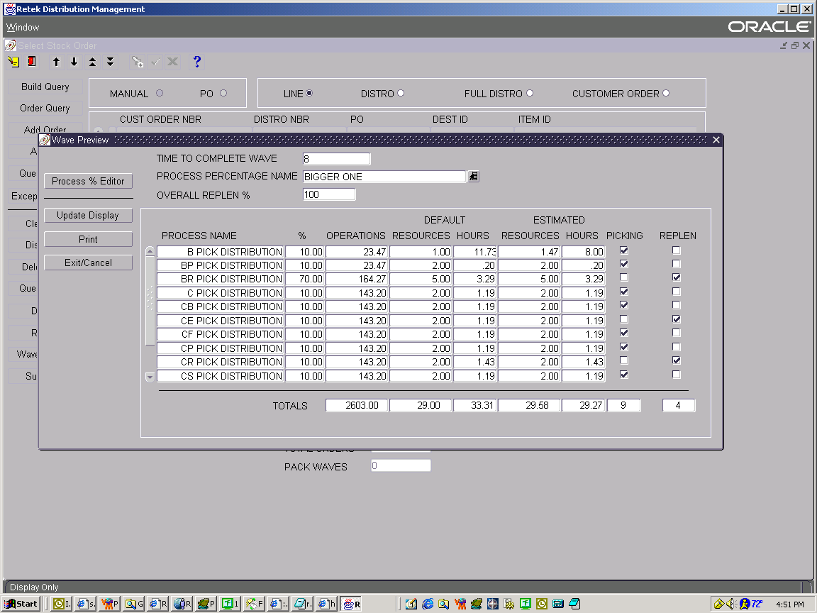

The logic for this change is based on calculations performed using percentages assigned to Process Names. Users will assign percentages to Process Names using the Process Defaults Editor. These values will then be used as multipliers against the orders selected for the wave.

Cubiscan Interface
Timely case and unit measurements are a must in a fast paced distribution system. This change will allow RDM initiated requests for case and unit dimensions to a Cubiscan machine. The results will be returned real time and displayed to the user to confirm the update in RDM.

Unit of Measure Display
This enhancement will allow users to define how they would like dimensions to be displayed to user. An example is that measurements taken in inches can be displayed in cubic feet.

Print and Email BOL and Manifest
The ability to email BOL paperwork will be added to the shipping functionality. Currently, RDM supports emailing the BOL. However, this enhancement will make it a simultaneous transaction triggered by the shipping of a trailer. Each ship destination will have a default email address stored as part of the shipping information.

ASN Pallet
RDM is being enhanced to support Tare (Pallet) Level ASNs. RDM will process Tare or Pallet ASNs that contain a Labeled Master with Unlabeled Children. During the receiving process the pallet level (T type) ASN may be handled by cross docking the entire pallet or breaking down the pallet for putaway.

Trailer Maintenance
Enhancements are being made to the trailer editor and trailer status screens to allow for Trailer User Definable Attributes. These attributes, such as length, refrigerated, etc., may be added to individual trailers. The trailer status screen will be modified to allow sorting by these attributes.

Multiple Seal Numbers for Outbound Trailers
The trailer shipping screen will be enhanced to allow for entry of multiple seal numbers. This will support a single trailer that is making multiple delivery stops. Each seal will be captured and produced on paperwork. This is user configurable.

Warning Messages for Close and Ship Trailer functions
The close and ship trailer functions are being enhanced to warn users that additional tasks remain for destinations on the trailer. The type of tasks that will prompt warnings are user configurable.

Interface to a 3rd Party Routing Package
A new interface will be developed to allow data transfer to a 3rd Party routing package. Data passed will include destination total cube and weight. Routing information will be taken into RDM and used to order and stage outbound picks based upon the provided routing information.

Pallet Let Down
Replenishment is being enhanced to provide more flexibility for distribution centers with limited case picking equipment. This user configurable replenishment type will create bulk replenishments from reserve where less than the full pallet quantity is required for replenishment. Users will be directed to replenish cases, and the remaining pallet will be returned to reserve.
The concept of pallet let down allows for full pallet movements out of reserve when less than a full pallet is needed for replenishment. Pallet let down allows a user to bulk pick out of reserve, complete the desired replenishments, and return the pallet to reserve. This eliminates the need to case pick out of high-bay locations for replenishments.
The determination of pallet let down is done at the process-level. Pallet let down is a Process used by Distribution. If a user assigns a pallet let down process to a forward picking location as well as a reserve location, this functionality calls for a pallet let down movement from reserve to the forward location. By configuring pallet let down at the process-level, users are able to configure both the locations (reserve and forward) that support pallet let down, as well as the priority by which items are let down from reserve. For example, a DC manager will be able to prioritize certain items to replenish in bulk first, then pallet let down. Additionally, some locations/items will not require less than full pallet replenishments. In these circumstances, the location is not be assigned a pallet let down process.

